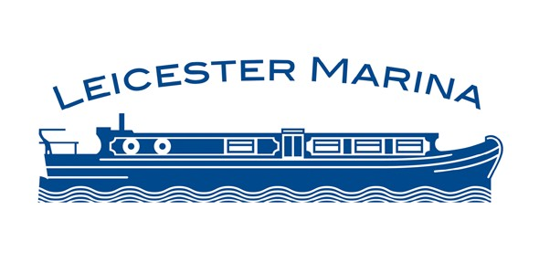

Brokerage Information

Name of Boat
Boat Builder Boat Model
Type Cruiser Narrow Boat Year of construction
Length Beam Hull Type Engine
Fuel Type
When serviced last
Boat Safety Certificate (Y) Expiry date (N)
When Blacked last Anodes replaced (Y) date (N) When anti fouled last
Interior of boat

No of Berths
Cooker Mains Electric/Gas Oven/Hob Microwave Fridge Mains Electric/12v/Gas
Toilet Elson/Pump out

Bathroom Bath Tub/Shower
Heating Diesel/Gas/Electric Wood burning stove/Multi fuel stove

Leicester Marina will use the above information to advertise the boat on their website, via social media, and on Apollo Duck and will conduct viewings and act as the contact for potential buyers.

I hereby certify that the above information is correct and upon sale a brokerage fee, in accordance with Leicester Marina’s Terms and Conditions (paragraph 7) will be paid within 7 days.
Signed ..........................................................................................
Print Name ..............................................................................

